

**Chapter 03: Sorting Algorithms**

HND Computing

BCAS Campus, Kalmunai

By: Eng. A.L. Jubailah Begum

DATA STRUCTURES & ALGORITHMS

Sorting Algorithms

A Sorting Algorithm is used to rearrange a given array or list elements according to a comparison operator on the elements. The comparison operator is used to decide the new order of element in the respective data structure.

**For example**: The below list of characters is sorted in increasing order of their ASCII values. That is, the character with lesser ASCII value will be placed first than the character with higher ASCII value.

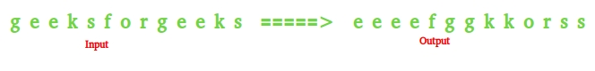

A sorting algorithm is an algorithm that puts elements of a list in a certain order. The most used orders are numerical order. Efficient sorting is important to optimize the use of other algorithms that require sorted lists to work correctly.

We need to do sorting for the following reasons:

a) By keeping a data file sorted, we can do binary search on it.

b) Doing certain operations, like matching data in two different files, become much faster.

There are various methods for sorting: Bubble sort, Insertion sort, Selection sort, Quick sort, Heap sort, Merge sort…. They have different average and worst case behaviors.





